**AFTERNOON CAR POOL PROCEDURES**

All Cars **MUST** enter Davis Drive Elementary by turning right from Collins Road into the Davis Drive parking lot.(Please do NOT attempt to enter the parking lot by driving up Collins Drive and turning left.) You must drive around to Waldo Rood and get into the one car pool line going in the one direction.

1. Car pool line forms on Collins Road. Turn RIGHT into the Davis Drive Parking lot.

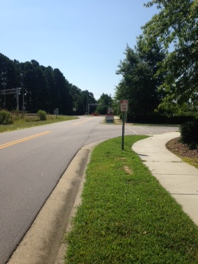

2. You will proceed straight through the parking lot.

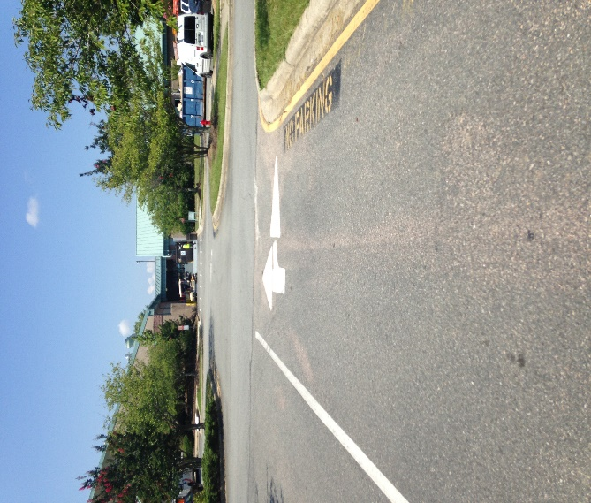

3. You will turn left to drive along-side the building.

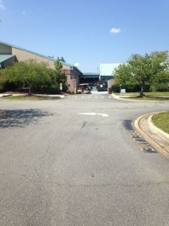

4. Turn right toward the Main Entrance.

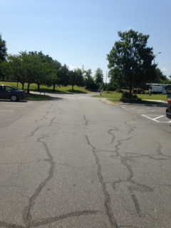

5. You will then be directed to stop at one of the shapes painted on the sidewalk for your student(s) to be dismissed.

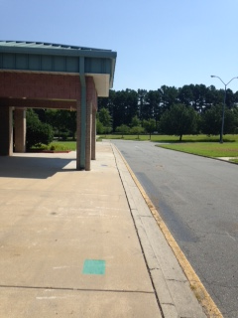

6. When the car in front of you begins to move, you will exit ONLY to Collins Road by turning the curve and proceeding back through the parking lot.

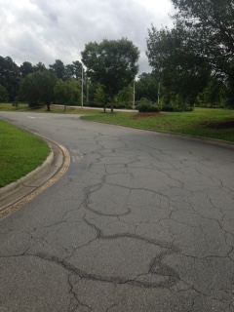

7. Follow the parking lot.

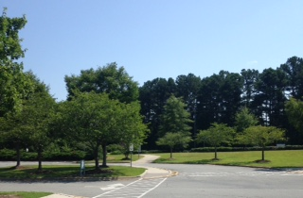

8. You will then turn RIGHT to exit onto Collins Road.

